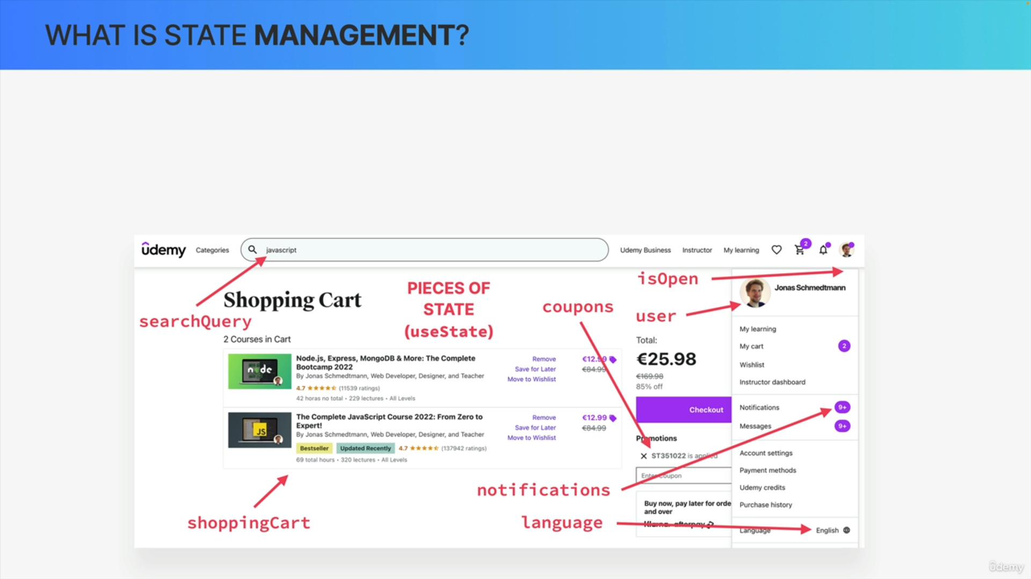

State is the most important concept in React. Therefore, managing state is the most important aspect when it comes to thinking in React.

We can use the useState function to create multiple pieces of state in order to track data that changes over the life cycle of an application.

How do we know that we even need all of these pieces of state? How do we know where exactly to place them inside the code?

That's where state management comes into play.

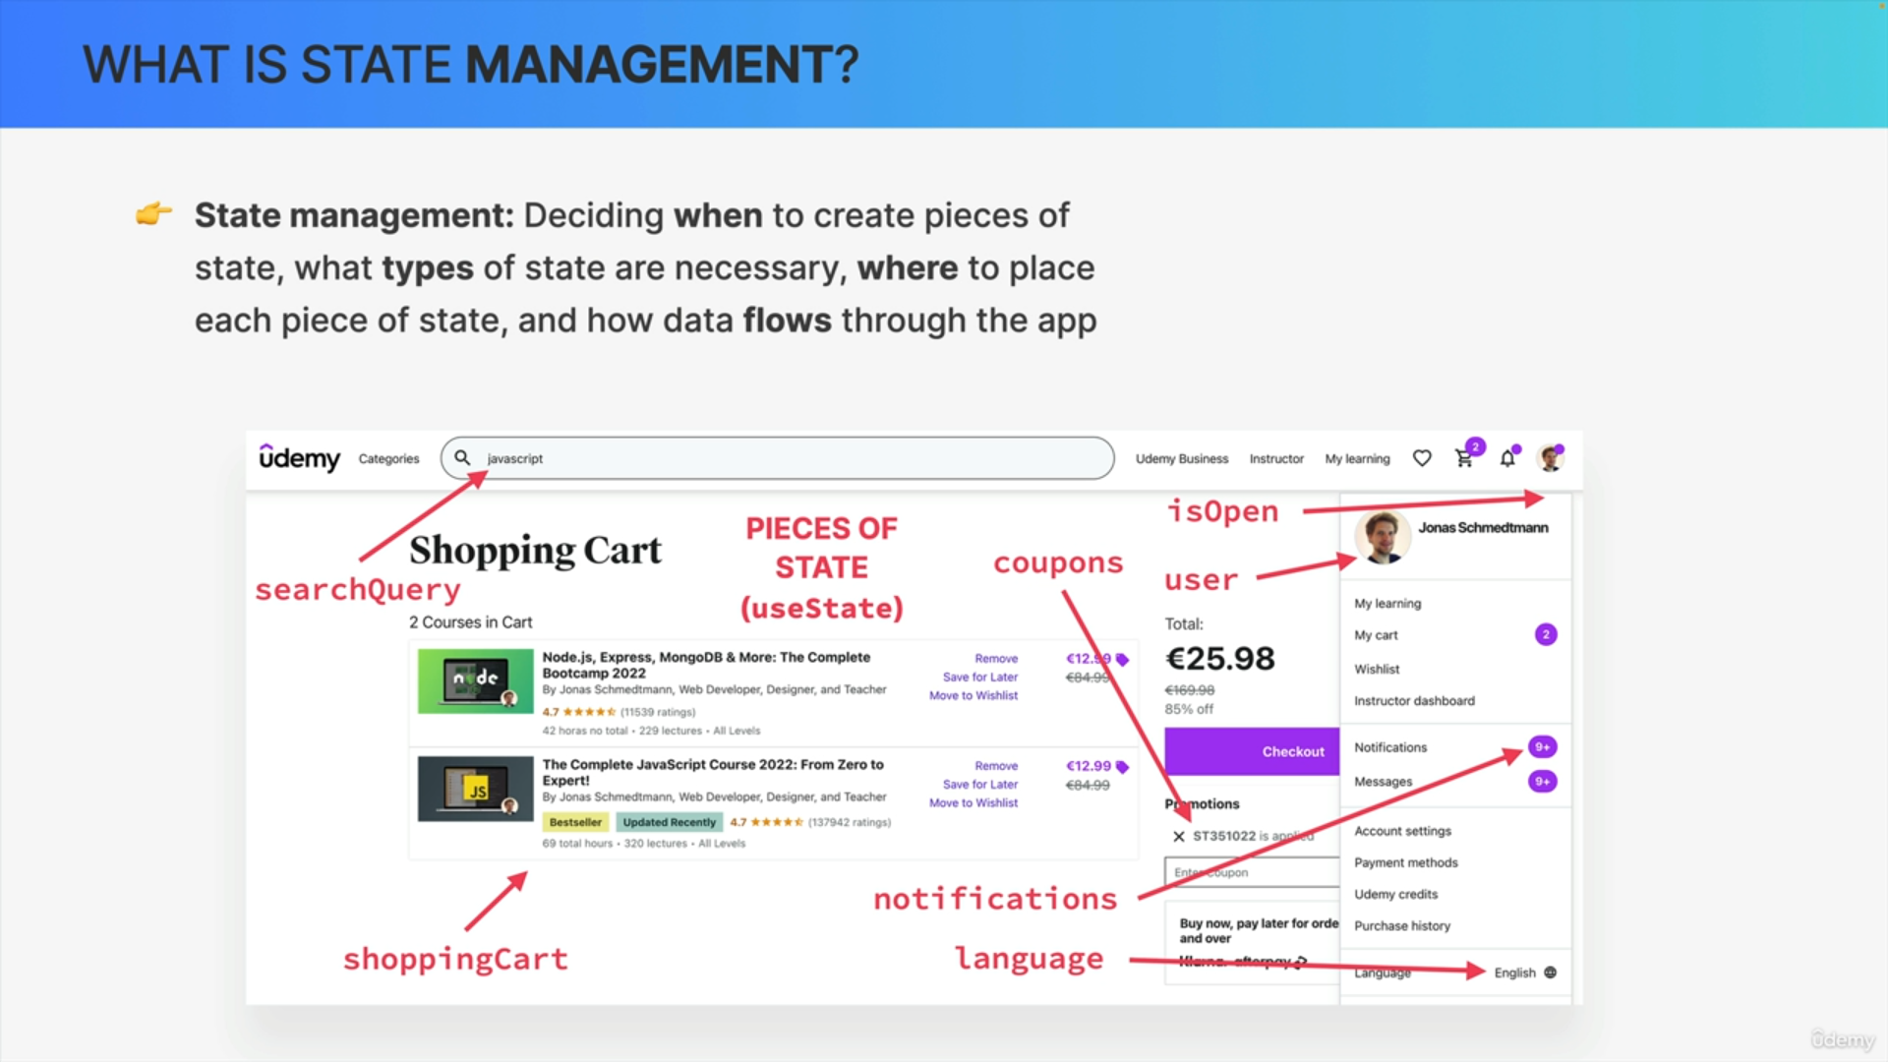

We can think of state management as deciding when we need to create new pieces of state, what types of state we need, where to place each piece of state inside our code base, and also how all the data should flow through the app.

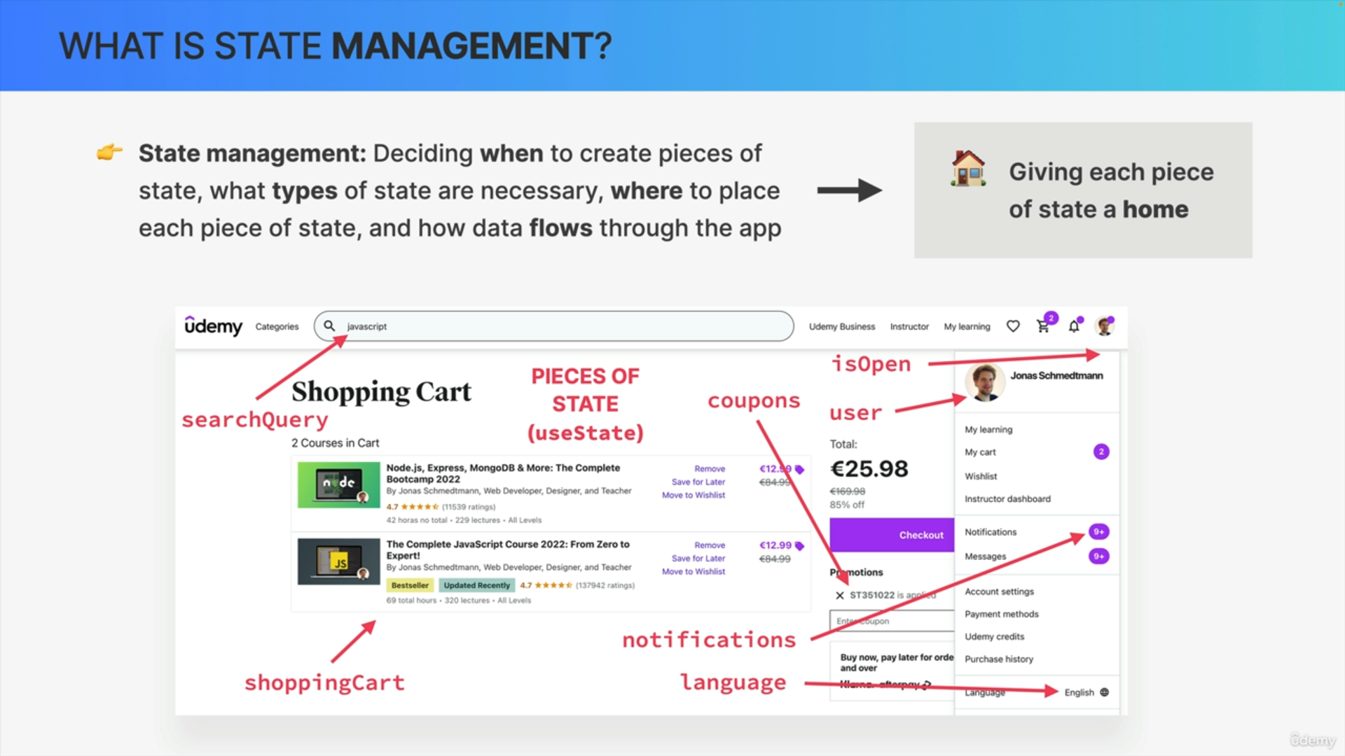

State management is basically giving each piece of state a home within our code base.

As an application grows, the need to find the right home for each piece of state start to become really important, no matter if that home is the component where we first need that state, some parent component or even global state.

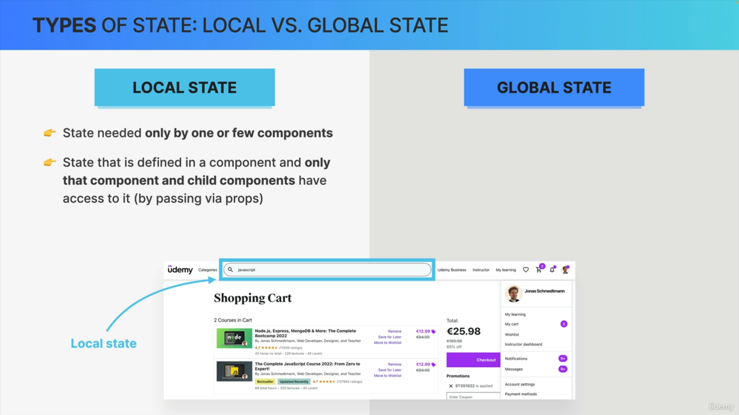

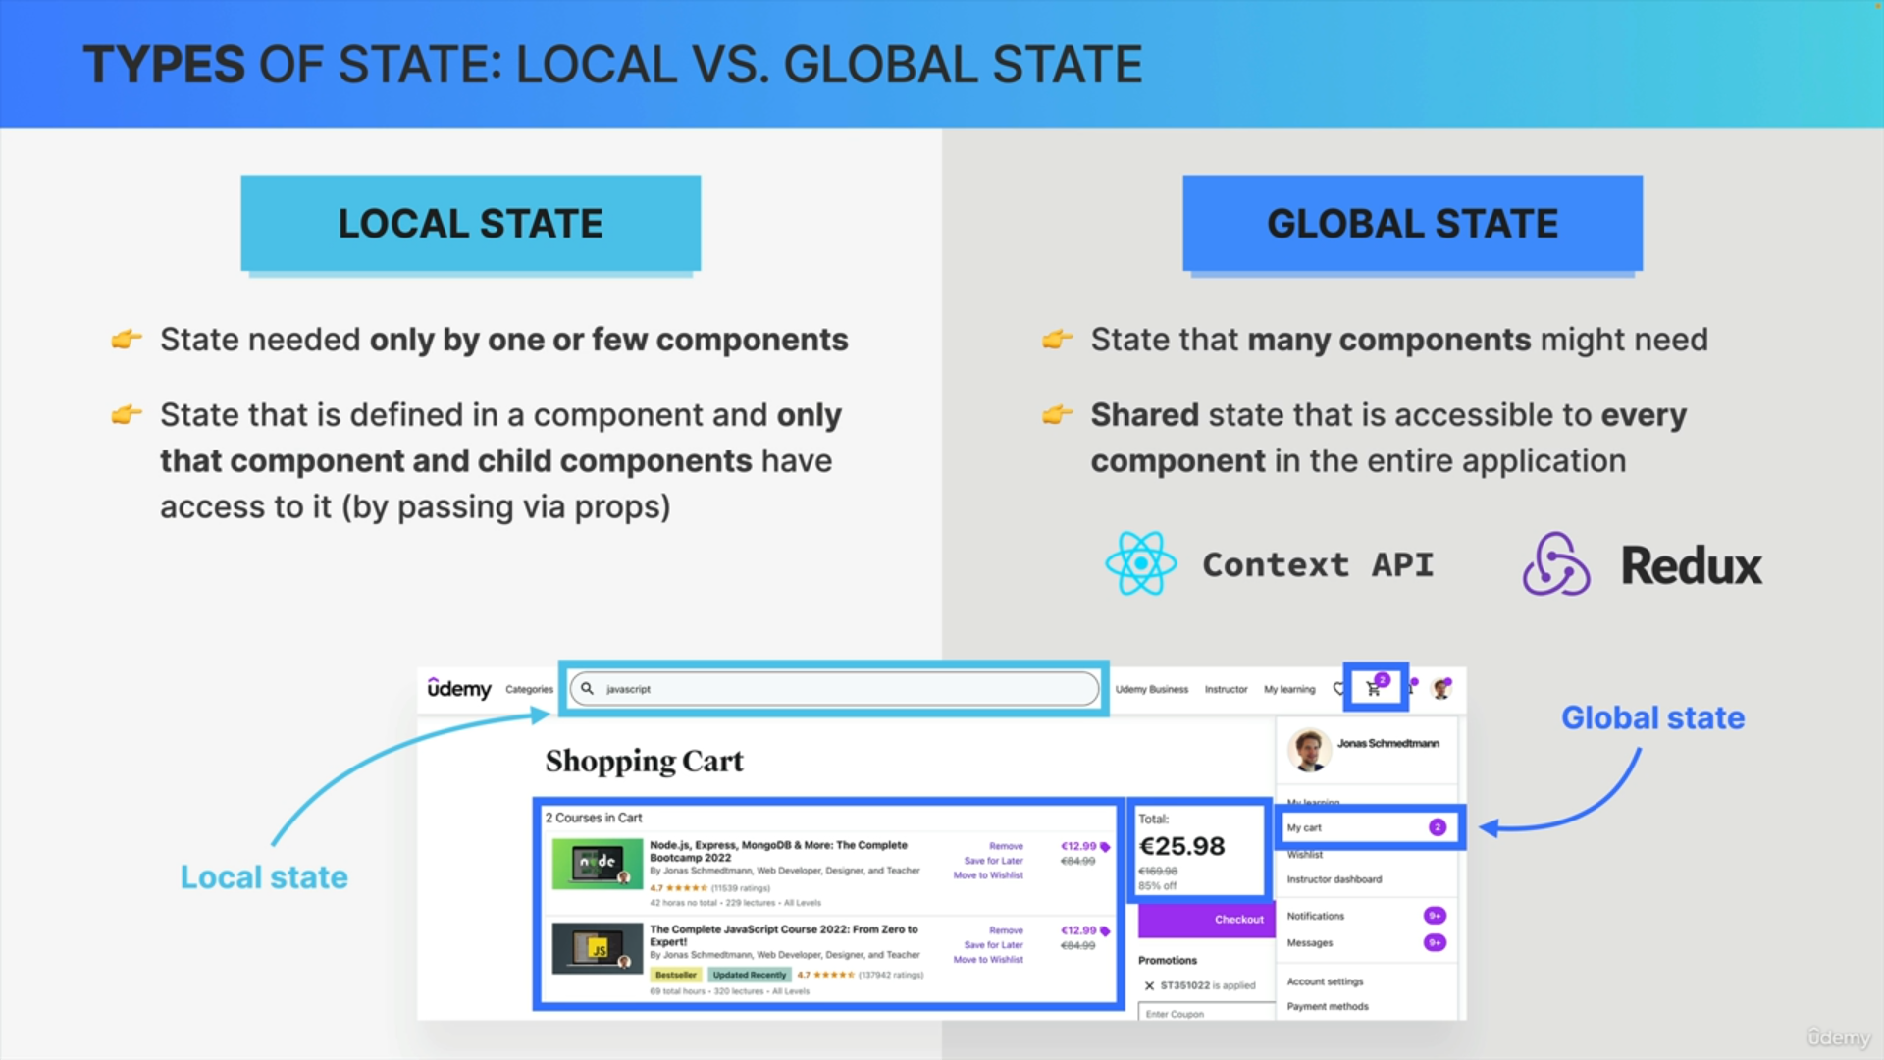

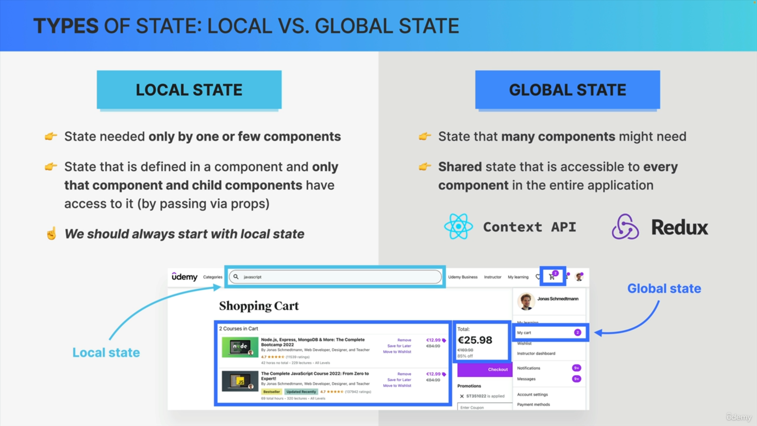

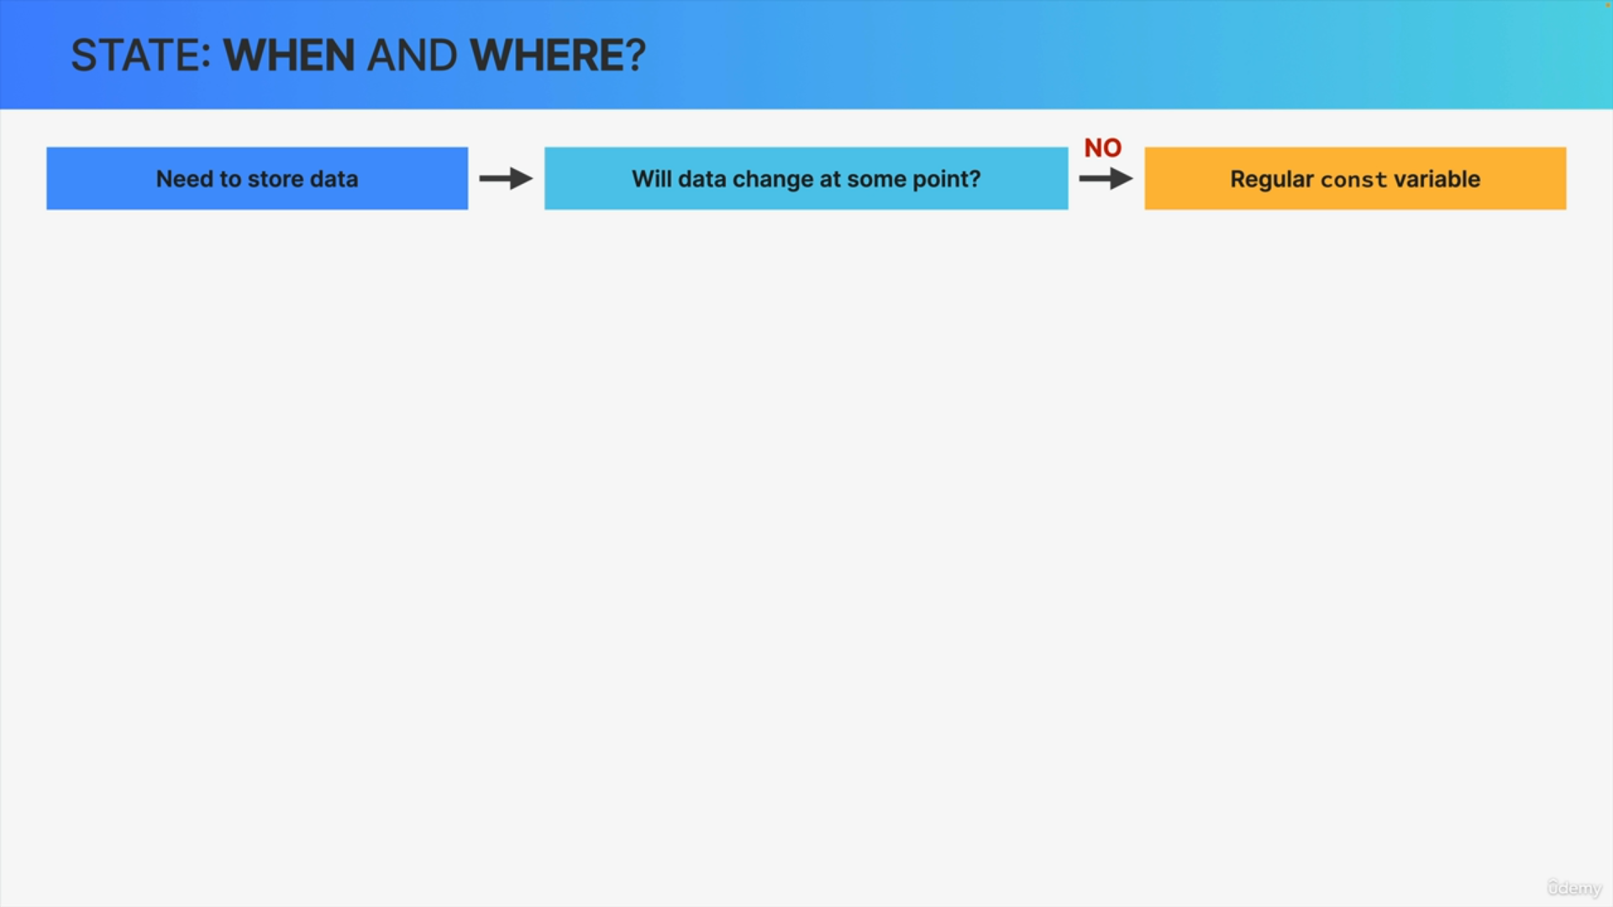

It all starts with you realizing that you need to store some data. Now when this happens, the first question to ask is, will the data change at some point in time?

If the answer is no then all you need is a regular variable i.e. a const variable.

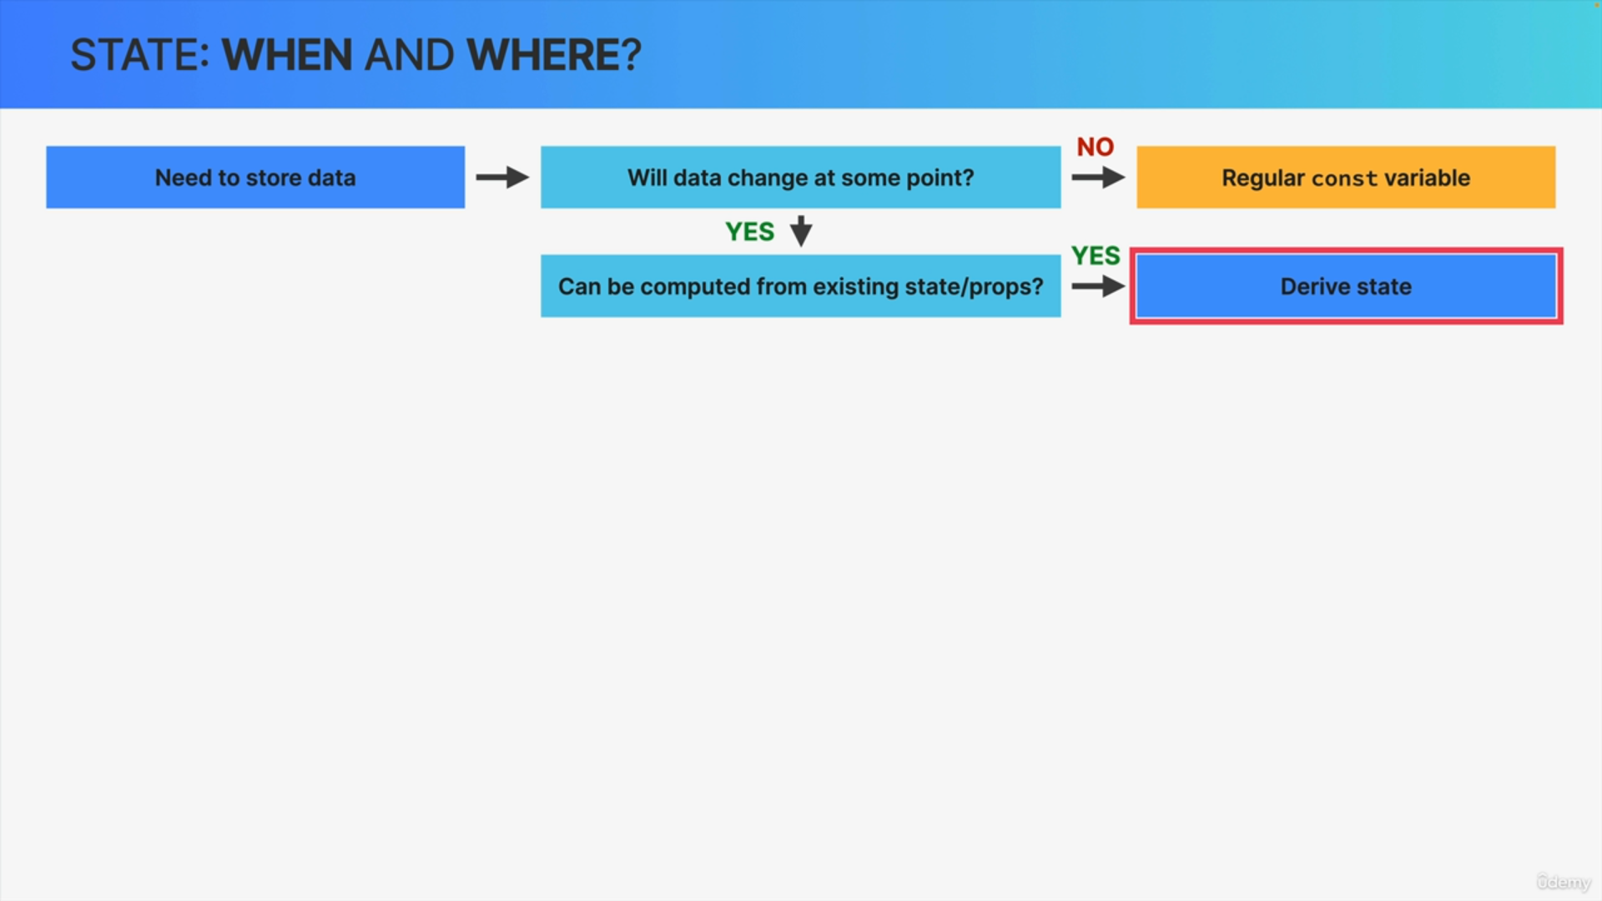

If the data does need to change in the future, the next question is, it is possible to compute or to calculate this new data from an existing piece of state or props?

If that's the case, then you should derive the state.

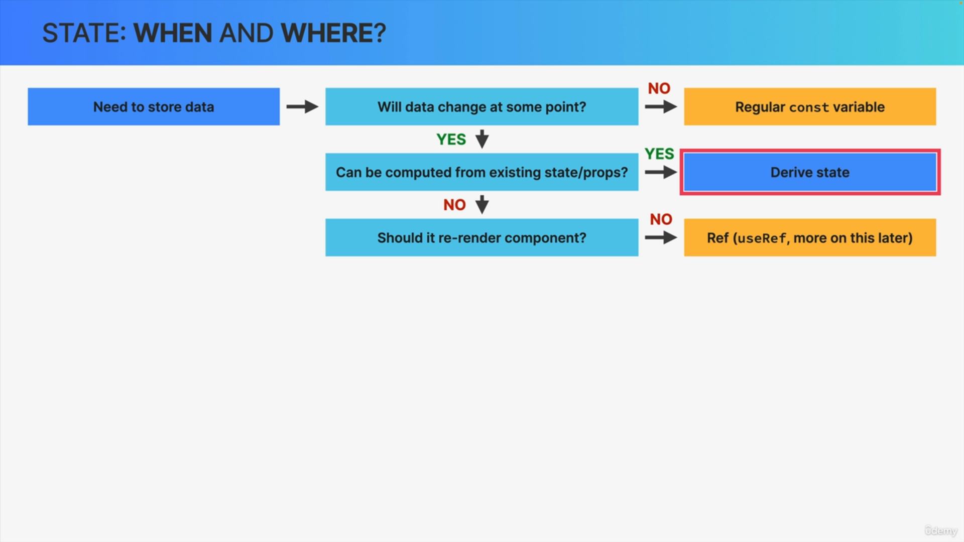

However, most of the time you cannot derive state. So in that case, you need to ask yourself whether updating the state should re-render the component.

Updating state always re-renders a component but there is actually something called a Ref which persists data over time like regular state but does not re-render a component.

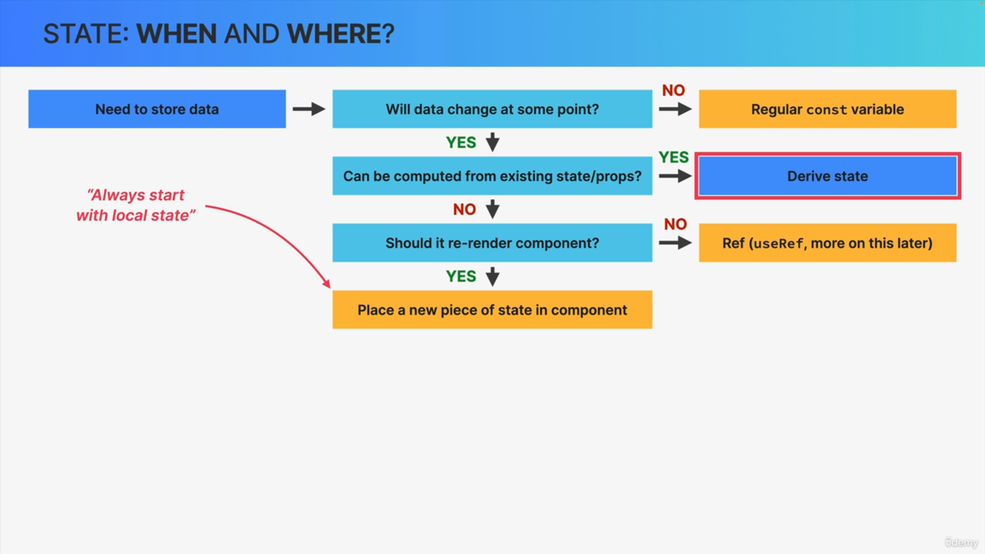

However, most of the time you actually do want state to re-render the component.

So, what you do is to create a new piece of state using the useState function and you then place that new piece of state into the component that you are currently building. So that's the always start with local state guideline.

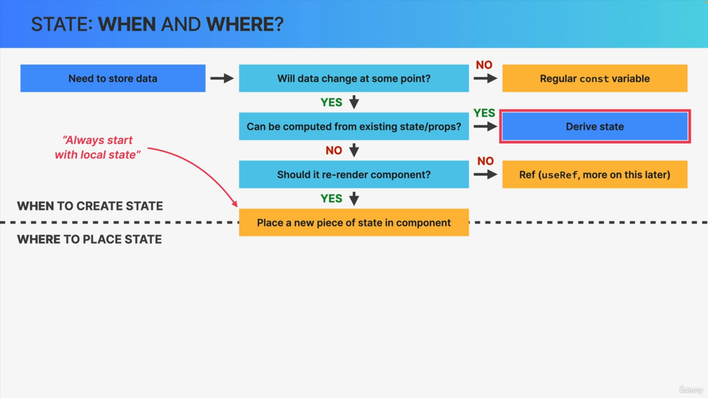

With this, we have completed the decision process of when to create state.

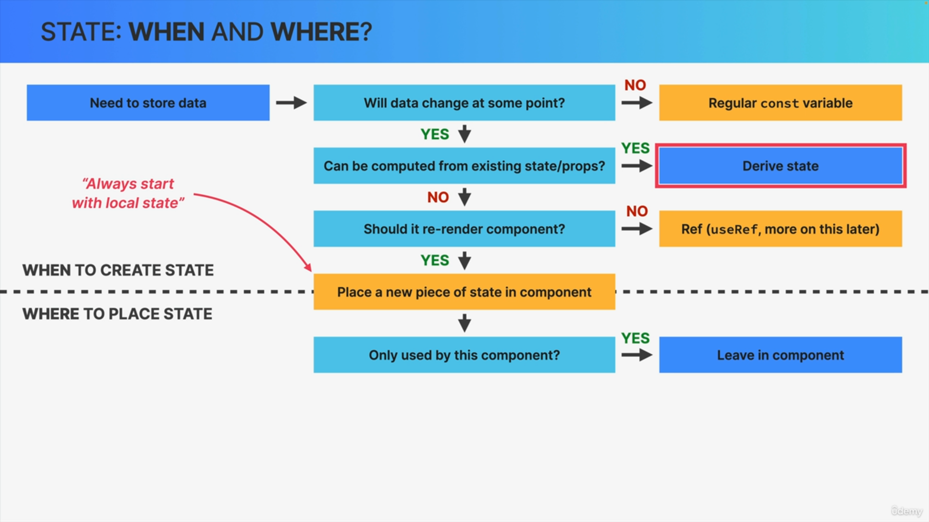

If the state variable that we just created is only used by the current component then simply leave it in that component and you're done.

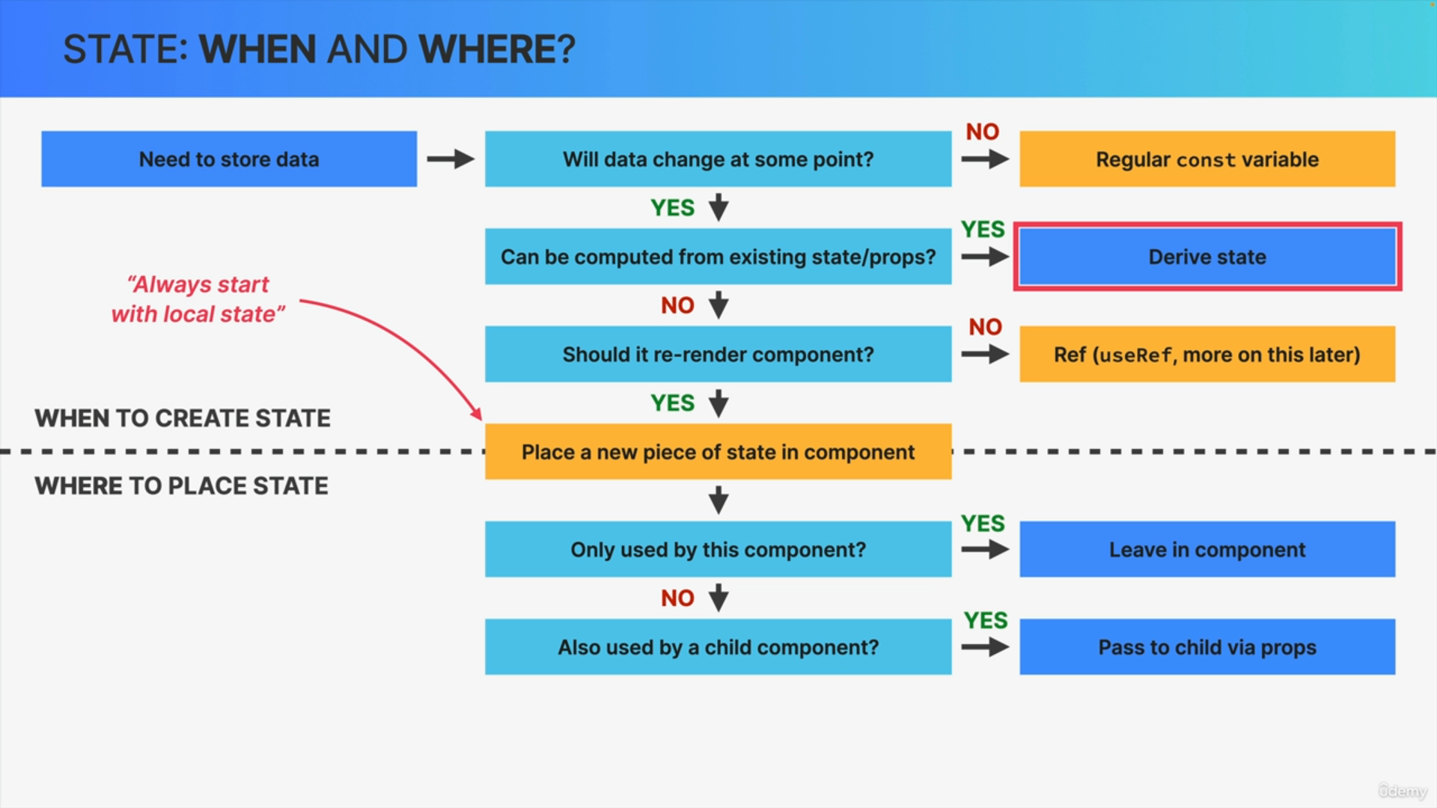

However, the state variable might also be necessary for a child component. In that case, simply pass the state down into the child component by using props.

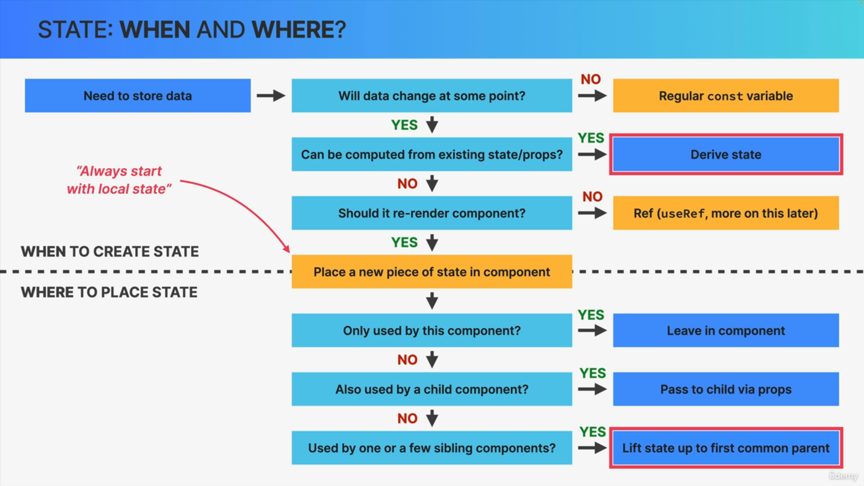

If the state variable is also necessary for one or a few sibling components or even for a parent component of your current component, it's time to move that state to the first common parent component. In React, this is what we call lifting state up.

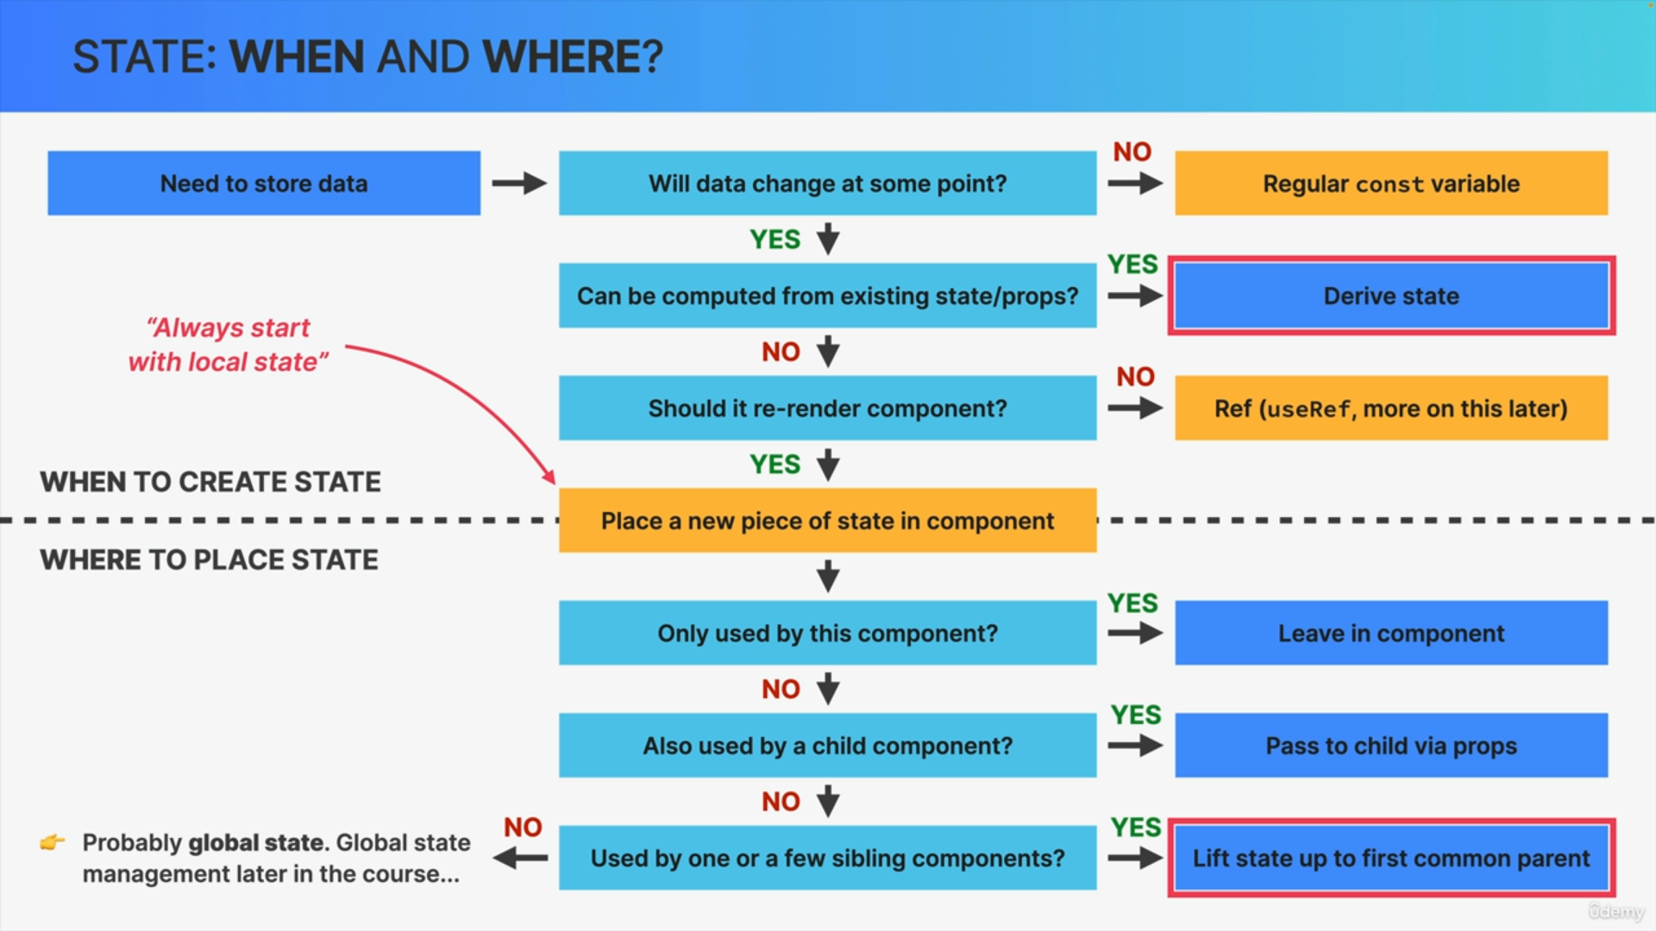

Finally, the state variable might be needed in even more than just a few siblings. So, it might be necessary all over the place in the component tree.

In this case we use global state.